exp6)-GROUP BY ,HAVING,ORDER BY

1)GROUP BY

2)ORDER BY

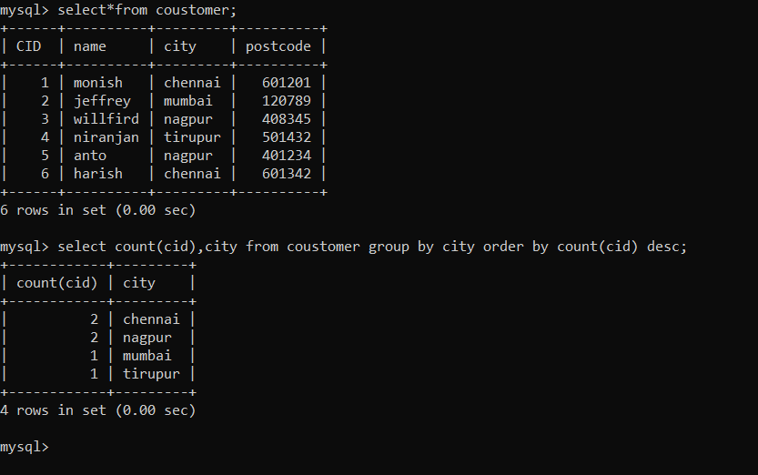

3)having clause

